FLIGHT BOOKING SYSTEM

18CSC209J - Database Management System and Cloud Integration Services

Mini Project Report

Submitted by

MAHESH KANDULA [Reg. No.: RA2111028010076]
B.Tech. CSE - CC

PRASANTH SAI[Reg. No.: RA2111028010142]
B.Tech. CSE - CC



DEPARTMENT OF NETWORKING AND COMMUNICATION
SCHOOL OF COMPUTING
COLLEGE OF ENGINEERING AND TECHNOLOGY
SRM INSTITUTE OF SCIENCE AND TECHNOLOGY
(Under Section 3 of UGC Act, 1956)
S.R.M. NAGAR, KATTANKULATHUR – 603 203
KANCHEEPURAM DISTRICT
MAY 2023

TABLE OF CONTENTS

Chapter No. | Title | Page No.
1. | Abstract | 3
2. | Introduction | 4
3. | Problem Statement | 4
4. | Module Description | 5
5. | Use case diagram | 6
6. | ER diagram | 7
7. | Database Creation using DDL and DML | 8
8. | Normalization of Database | 18
9. | Implementation using Dynamo DB | 19
10. | Conclusion | 20
11 | Appendix I – Screenshot | 21
12 | Appemdix II – Github Profile | 25
13 | Appendix III – AWS Course Completion certificate | 26

ABSTRACT

The Basic Flight Booking System with PHP and SQL is a web-based application that allows users to search for flights and make bookings. The system is designed to be user-friendly and efficient, with a simple and intuitive interface that guides users through the booking process.

The system is built using PHP, a popular server-side scripting language, and SQL, a widely used relational database management system. These technologies enable the system to store and retrieve data efficiently, ensuring that users can access up-to-date flight information and make bookings in real-time.

The system has several key features, including a flight search function that allows users to search for flights based on their preferred dates, destinations, and other criteria. The search function uses an intuitive interface that guides users through the process, making it easy to find the right flight.

Once a flight is selected, the system prompts the user to enter their personal and payment information to complete the booking. The system uses secure payment processing to ensure that user data is protected and that transactions are completed securely.

The system also includes an administrative panel that allows airline staff to manage flight schedules, update flight information, and monitor bookings. The administrative panel provides a centralized location for managing flight information, reducing the risk of errors and ensuring that information is up-to-date.

Overall, the Basic Flight Booking System with PHP and SQL is an efficient and user-friendly application that simplifies the flight booking process. It provides users with an easy-to-use interface that guides them through the booking process, while also providing administrators with the tools they need to manage flight schedules and bookings. With its secure payment processing and robust data management capabilities, the system is an ideal solution for airlines and travel agencies looking to streamline their booking process and provide their customers with a top-notch experience.

INTRODUCTION
The Transport industry has been undergoing a digital transformation in recent years. One of the areas that have witnessed significant changes is the booking process. With the increasing demand for Travel services, the traditional methods of appointment booking have become cumbersome and inefficient. To overcome these challenges, airports and customers are adopting online platforms to streamline the flight booking process. The Flight Booking System is one such platform that aims to provide a user-friendly interface to book, manage and pay for Flights.

PROBLEM STATEMENT
The traditional methods of appointment booking in Travelling via Air transport facilities have been inefficient and time-consuming. Passengers have to physically visit the Airport to book an appointment for their preferred flight . This process involves long wait times and leads to overcrowding in the waiting areas. Furthermore, passengers often have to wait for long periods to receive their tickets and boarding passes.
Additionally, Airport Management face challenges in managing their Flight schedules and payment processes. The traditional methods of appointment booking are manual and prone to errors, which can lead to scheduling conflicts, missed tickets of customers and delayed payments.
The Flight Appointment Booking System aims to address these challenges by providing a user-friendly interface that enables passengers to easily book, manage and pay for travelling. Airport management can manage their flight schedules, Issue tickets and view travel history, while admins can manage flight schedules and view passenger details. By adopting this platform, Airports can improve passenger experience, reduce waiting times, and enhance operational efficiency.
MODULE DESCRIPTION

The Hospital Appointment Booking System is a comprehensive platform that consists of several modules that work together to provide a seamless appointment booking process. These modules include:

1.Login: This module enables passengers and admins to create an account and log in to the system. Once logged in, users can access their profiles.

2. Flight Booking: This module enables passengers to book flights for their preferred flights. They can choose the date and time of the travel and select their preferred flight from the list of available flights.

3. Fight History: This module enables users to view their travel history.

4. Payment: This module enables users to pay their bill online and make the payment using a secure payment gateway.

5. Flight Status: This module enables users to check the status of their flight travel.

6. Flight Manager : This allows admins to add/delete/modify flights into the currents list of flights

Overall, the Flight Booking System is a comprehensive platform that provides a range of features to streamline the flight booking process. The modules work together to enhance patient experience, improve Airport Management efficiency and optimize travel operations.

USE-CASE DIAGRAM

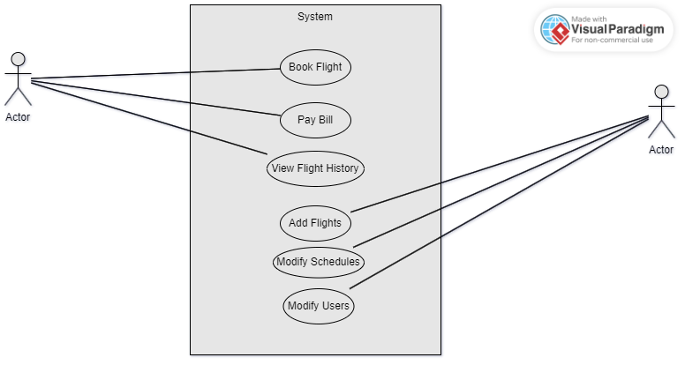

ER DIAGRAM

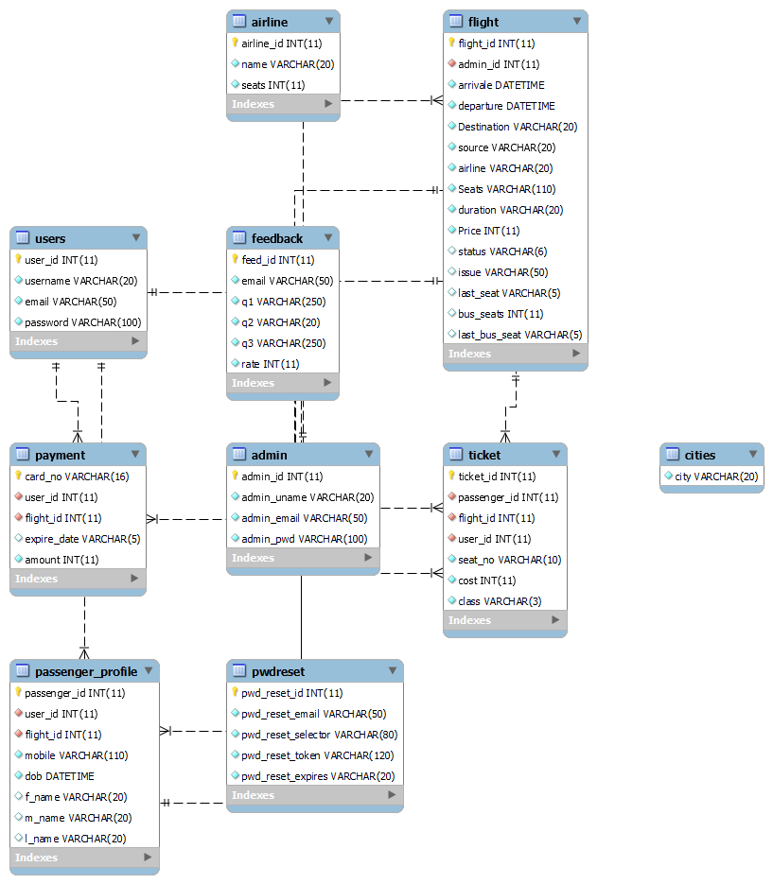

DATABASE CREATION USING DDL AND DML

-- phpMyAdmin SQL Dump
-- version 4.6.5.2
-- https://www.phpmyadmin.net/
--
-- Host: 127.0.0.1
-- Generation Time: Jul 05, 2023 at 06:36 PM
-- Server version: 5.6.21
-- PHP Version: 5.6.3

SET SQL_MODE = "NO_AUTO_VALUE_ON_ZERO";
SET time_zone = "+00:00";

/*!40101 SET @OLD_CHARACTER_SET_CLIENT=@@CHARACTER_SET_CLIENT */;
/*!40101 SET @OLD_CHARACTER_SET_RESULTS=@@CHARACTER_SET_RESULTS */;
/*!40101 SET @OLD_COLLATION_CONNECTION=@@COLLATION_CONNECTION */;
/*!40101 SET NAMES utf8mb4 */;

--
-- Database: `ofbsphp`
--

-- --------------------------------------------------------

--
-- Table structure for table `admin`
--

CREATE TABLE `admin` (
`admin_id` int(11) NOT NULL,
`admin_uname` varchar(20) NOT NULL,
`admin_email` varchar(50) NOT NULL,
`admin_pwd` varchar(100) NOT NULL
) ENGINE=InnoDB DEFAULT CHARSET=latin1;

--
-- Dumping data for table `admin`
--

INSERT INTO `admin` (`admin_id`, `admin_uname`, `admin_email`, `admin_pwd`) VALUES
(1, 'admin', 'admin@mail.com', '$2y$10$KRXGkY.dxYjD8FLZclW/Tu04wl76lD7IA4Z3nAsxtpdZxHNbYo4ZW');

-- --------------------------------------------------------

--
-- Table structure for table `airline`
--

CREATE TABLE `airline` (
`airline_id` int(11) NOT NULL,
`name` varchar(20) NOT NULL,
`seats` int(11) NOT NULL
) ENGINE=InnoDB DEFAULT CHARSET=latin1;

--
-- Dumping data for table `airline`
--

INSERT INTO `airline` (`airline_id`, `name`, `seats`) VALUES
(1, 'Air India Airways', 165),
(2, 'Air Asia Airline', 220),
(3, 'Vistara Airways', 125),
(4, 'Ethihad Airways', 210),
(5, 'Qatar Airways', 185),
(6, 'Indigo', 200),
(7, 'GoldStar Airways', 205),
(8, 'Singapore Airways', 158),
(9, 'British Airways', 210),
(10, 'Emirates Airways', 215),
(11, 'Spicejet Airlines', 135);

-- --------------------------------------------------------

--
-- Table structure for table `cities`
--

CREATE TABLE `cities` (
`city` varchar(20) NOT NULL
) ENGINE=InnoDB DEFAULT CHARSET=latin1;

--
-- Dumping data for table `cities`
--

INSERT INTO `cities` (`city`) VALUES
('San Jose'),
('Chicago'),
('Chennai'),
('Delhi'),
('Sharjah'),
('Banglore'),
('Hyderabad'),
('Abu Dhabi'),
('Doha'),
('Dubai'),
('London'),
('New York'),
('Los Angeles'),
('San Diego'),
('Moscow'),
('Paris'),
('Rome'),
('Berlin');

-- --------------------------------------------------------

--
-- Table structure for table `feedback`
--

CREATE TABLE `feedback` (
`feed_id` int(11) NOT NULL,
`email` varchar(50) NOT NULL,
`q1` varchar(250) NOT NULL,
`q2` varchar(20) NOT NULL,
`q3` varchar(250) NOT NULL,
`rate` int(11) NOT NULL
) ENGINE=InnoDB DEFAULT CHARSET=latin1;

-- --------------------------------------------------------

--
-- Table structure for table `flight`
--

CREATE TABLE `flight` (
`flight_id` int(11) NOT NULL,
`admin_id` int(11) NOT NULL,
`arrivale` datetime NOT NULL,
`departure` datetime NOT NULL,
`Destination` varchar(20) NOT NULL,
`source` varchar(20) NOT NULL,
`airline` varchar(20) NOT NULL,
`Seats` varchar(110) NOT NULL,
`duration` varchar(20) NOT NULL,
`Price` int(11) NOT NULL,
`status` varchar(6) DEFAULT NULL,
`issue` varchar(50) DEFAULT NULL,
`last_seat` varchar(5) DEFAULT '',
`bus_seats` int(11) DEFAULT '20',
`last_bus_seat` varchar(5) DEFAULT ''
) ENGINE=InnoDB DEFAULT CHARSET=latin1;

--
-- Dumping data for table `flight`
--

INSERT INTO `flight` (`flight_id`, `admin_id`, `arrivale`, `departure`, `Destination`, `source`, `airline`, `Seats`, `duration`, `Price`, `status`, `issue`, `last_seat`, `bus_seats`, `last_bus_seat`) VALUES
(1, 1, '2023-05-01 10:03:00', '2023-05-01 09:01:00', 'Chicago', 'San', 'Air India Airways', '63', '1', 175, '', '', '21B', 20, ''),
(2, 1, '2023-05-03 11:15:00', '2023-05-03 10:05:00', 'Delhi', 'Chennai', 'Air India Airways', '61', '1', 185, 'arr', '', '21D', 20, ''),
(3, 1, '2023-05-03 12:13:00', '2023-05-03 10:13:00', 'Sharjah', 'Chennai', 'Vistara Airways', '123', '2', 205, 'arr', '', '21B', 20, ''),
(4, 1, '2023-05-03 16:30:00', '2023-05-03 15:26:00', 'Sharjah', 'Delhi', 'Air Asia Airline', '220', '1', 155, 'issue', '120', '', 20, ''),
(5, 1, '2023-05-03 15:30:00', '2023-05-03 12:30:00', 'Banglore', 'Delhi', 'Vistara Airways', '125', '3', 326, '', '', '', 20, ''),
(6, 1, '2023-05-03 17:55:00', '2023-05-03 15:30:00', 'Banglore', 'Sharjah', 'Vistara Airways', '125', '2', 285, '', '', '', 20, ''),
(7, 1, '2023-05-03 20:50:00', '2023-05-03 18:50:00', 'Hyderabad', 'Banglore', 'Vistara Airways', '125', '2', 265, '', '', '', 20, ''),
(8, 1, '2023-05-04 00:55:00', '2023-05-03 17:00:00', 'New York', 'Hyderabad', 'Qatar Airways', '183', '7', 615, 'arr', '', '21B', 20, ''),
(9, 1, '2023-05-03 17:09:00', '2023-05-03 16:05:00', 'Banglore', 'Chennai', 'Ethihad Airways', '210', '1', 155, '', '', '', 20, ''),
(10, 1, '2023-05-04 13:10:00', '2023-05-04 11:05:00', 'Abu Dhabi', 'Delhi', 'Air India Airways', '165', '2', 200, '', '', '', 20, ''),
(11, 1, '2023-05-03 19:10:00', '2023-05-03 18:05:00', 'Doha', 'Dubai', 'Air Asia Airline', '220', '1', 165, '', '', '', 20, ''),
(12, 1, '2023-05-03 21:10:00', '2023-05-03 19:05:00', 'Chicago', 'London', 'Ethihad Airways', '210', '2', 320, '', '', '', 20, ''),
(13, 1, '2023-05-03 13:50:00', '2023-05-03 12:56:00', 'Chennai', 'Chicago', 'Air India Airways', '165', '1', 110, 'issue', '110', '', 20, ''),
(14, 1, '2023-05-03 11:08:00', '2023-05-03 09:07:00', 'New York', 'San', 'Vistara Airways', '125', '2', 195, 'issue', '120', '', 20, ''),
(15, 1, '2023-05-03 10:10:00', '2023-05-03 08:10:00', 'Sharjah', 'Chicago', 'Ethihad Airways', '210', '2', 125, 'issue', '120', '', 20, ''),
(16, 1, '2023-05-03 18:10:00', '2023-05-03 16:09:00', 'Dubai', 'San', 'Qatar Airways', '185', '2', 220, 'dep', '', '', 20, ''),
(17, 1, '2023-05-03 17:10:00', '2023-05-03 16:10:00', 'San', 'Banglore', 'Air Asia Airline', '220', '1', 125, 'arr', '', '', 20, ''),
(18, 1, '2023-05-03 19:15:00', '2023-05-03 16:12:00', 'San', 'Dubai', 'Air India Airways', '165', '3', 275, 'dep', '', '', 20, ''),
(19, 1, '2023-05-03 23:40:00', '2023-05-03 20:31:00', 'Delhi', 'New York', 'British Airways', '210', '3', 295, '', '', '', 20, ''),
(20, 1, '2023-05-03 23:58:00', '2023-05-03 22:14:00', 'San Diego', 'Los Angeles', 'British Airways', '208', '1', 185, 'dep', '', '21B', 20, ''),
(21, 1, '2023-05-04 10:14:00', '2023-05-03 23:15:00', 'Hyderabad', 'Moscow', 'Indigo', '200', '11', 965, '', '', '', 20, '');

-- --------------------------------------------------------

--
-- Table structure for table `passenger_profile`
--

CREATE TABLE `passenger_profile` (
`passenger_id` int(11) NOT NULL,
`user_id` int(11) NOT NULL,
`flight_id` int(11) NOT NULL,
`mobile` varchar(110) NOT NULL,
`dob` datetime NOT NULL,
`f_name` varchar(20) DEFAULT NULL,
`m_name` varchar(20) DEFAULT NULL,
`l_name` varchar(20) DEFAULT NULL
) ENGINE=InnoDB DEFAULT CHARSET=latin1;

--
-- Dumping data for table `passenger_profile`
--

INSERT INTO `passenger_profile` (`passenger_id`, `user_id`, `flight_id`, `mobile`, `dob`, `f_name`, `m_name`, `l_name`) VALUES
(1, 1, 1, '2147483647', '1995-01-01 00:00:00', 'Christine', 'M', 'Moore'),
(2, 2, 3, '2147483647', '1995-02-13 00:00:00', 'Henry', 'l', 'Stuart'),
(3, 3, 2, '2147483647', '1994-06-21 00:00:00', 'Andre', 'J', 'Atkins'),
(4, 4, 2, '2147483647', '1995-05-16 00:00:00', 'James', 'K', 'Harbuck'),
(5, 2, 8, '7854444411', '1995-02-13 00:00:00', 'Henry', 'l', 'Stuart'),
(6, 2, 20, '7412585555', '1995-02-13 00:00:00', 'Henry', 'l', 'Stuart');

-- --------------------------------------------------------

--
-- Table structure for table `payment`
--

CREATE TABLE `payment` (
`card_no` varchar(16) NOT NULL,
`user_id` int(11) NOT NULL,
`flight_id` int(11) NOT NULL,
`expire_date` varchar(5) DEFAULT NULL,
`amount` int(11) NOT NULL
) ENGINE=InnoDB DEFAULT CHARSET=latin1;

--
-- Dumping data for table `payment`
--

INSERT INTO `payment` (`card_no`, `user_id`, `flight_id`, `expire_date`, `amount`) VALUES
('1010555677851111', 4, 2, '10/26', 370),
('1020445869651011', 2, 20, '12/25', 370),
('1111888889897778', 2, 3, '12/25', 205),
('1400565800004478', 2, 8, '12/25', 1230),
('1458799990001450', 3, 2, '12/25', 185),
('4204558500014587', 1, 1, '02/25', 350);

-- --------------------------------------------------------

--
-- Table structure for table `pwdreset`
--

CREATE TABLE `pwdreset` (
`pwd_reset_id` int(11) NOT NULL,
`pwd_reset_email` varchar(50) NOT NULL,
`pwd_reset_selector` varchar(80) NOT NULL,
`pwd_reset_token` varchar(120) NOT NULL,
`pwd_reset_expires` varchar(20) NOT NULL
) ENGINE=InnoDB DEFAULT CHARSET=latin1;

-- --------------------------------------------------------

--
-- Table structure for table `ticket`
--

CREATE TABLE `ticket` (
`ticket_id` int(11) NOT NULL,
`passenger_id` int(11) NOT NULL,
`flight_id` int(11) NOT NULL,
`user_id` int(11) NOT NULL,
`seat_no` varchar(10) NOT NULL,
`cost` int(11) NOT NULL,
`class` varchar(3) NOT NULL
) ENGINE=InnoDB DEFAULT CHARSET=latin1;

--
-- Dumping data for table `ticket`
--

INSERT INTO `ticket` (`ticket_id`, `passenger_id`, `flight_id`, `user_id`, `seat_no`, `cost`, `class`) VALUES
(1, 1, 1, 1, '21A', 350, 'E'),
(2, 2, 3, 2, '21A', 205, 'E'),
(4, 3, 2, 3, '21A', 185, 'E'),
(6, 4, 2, 4, '21C', 370, 'E'),
(8, 5, 8, 2, '21A', 1230, 'E'),
(10, 6, 20, 2, '21A', 370, 'E');

-- --------------------------------------------------------

--
-- Table structure for table `users`
--

CREATE TABLE `users` (
`user_id` int(11) NOT NULL,
`username` varchar(20) NOT NULL,
`email` varchar(50) NOT NULL,
`password` varchar(100) NOT NULL
) ENGINE=InnoDB DEFAULT CHARSET=latin1;

--
-- Dumping data for table `users`
--

INSERT INTO `users` (`user_id`, `username`, `email`, `password`) VALUES
(1, 'christine', 'christine@mail.com', '$2y$10$KRXGkY.dxYjD8FLZclW/Tu04wl76lD7IA4Z3nAsxtpdZxHNbYo4ZW'),
(2, 'henry', 'henry@mail.com', '$2y$10$KRXGkY.dxYjD8FLZclW/Tu04wl76lD7IA4Z3nAsxtpdZxHNbYo4ZW'),
(3, 'andre', 'andre@mail.com', '$2y$10$KRXGkY.dxYjD8FLZclW/Tu04wl76lD7IA4Z3nAsxtpdZxHNbYo4ZW'),
(4, 'james', 'james@mail.com', '$2y$10$KRXGkY.dxYjD8FLZclW/Tu04wl76lD7IA4Z3nAsxtpdZxHNbYo4ZW');

--
-- Indexes for dumped tables
--

--
-- Indexes for table `admin`
--
ALTER TABLE `admin`
ADD PRIMARY KEY (`admin_id`);

--
-- Indexes for table `airline`
--
ALTER TABLE `airline`
ADD PRIMARY KEY (`airline_id`);

--
-- Indexes for table `feedback`
--
ALTER TABLE `feedback`
ADD PRIMARY KEY (`feed_id`);

--
-- Indexes for table `flight`
--
ALTER TABLE `flight`
ADD PRIMARY KEY (`flight_id`),
ADD KEY `admin_id` (`admin_id`);

--
-- Indexes for table `passenger_profile`
--
ALTER TABLE `passenger_profile`
ADD PRIMARY KEY (`passenger_id`),
ADD KEY `user_id` (`user_id`),
ADD KEY `flight_id` (`flight_id`);

--
-- Indexes for table `payment`
--
ALTER TABLE `payment`
ADD PRIMARY KEY (`card_no`),
ADD KEY `user_id` (`user_id`),
ADD KEY `flight_id` (`flight_id`);

--
-- Indexes for table `pwdreset`
--
ALTER TABLE `pwdreset`
ADD PRIMARY KEY (`pwd_reset_id`);

--
-- Indexes for table `ticket`
--
ALTER TABLE `ticket`
ADD PRIMARY KEY (`ticket_id`),
ADD KEY `user_id` (`user_id`),
ADD KEY `flight_id` (`flight_id`),
ADD KEY `passenger_id` (`passenger_id`);

--
-- Indexes for table `users`
--
ALTER TABLE `users`
ADD PRIMARY KEY (`user_id`);

--
-- AUTO_INCREMENT for dumped tables
--

--
-- AUTO_INCREMENT for table `admin`
--
ALTER TABLE `admin`
MODIFY `admin_id` int(11) NOT NULL AUTO_INCREMENT, AUTO_INCREMENT=2;
--
-- AUTO_INCREMENT for table `airline`
--
ALTER TABLE `airline`
MODIFY `airline_id` int(11) NOT NULL AUTO_INCREMENT, AUTO_INCREMENT=15;
--
-- AUTO_INCREMENT for table `feedback`
--
ALTER TABLE `feedback`
MODIFY `feed_id` int(11) NOT NULL AUTO_INCREMENT;
--
-- AUTO_INCREMENT for table `flight`
--
ALTER TABLE `flight`
MODIFY `flight_id` int(11) NOT NULL AUTO_INCREMENT, AUTO_INCREMENT=22;
--
-- AUTO_INCREMENT for table `passenger_profile`
--
ALTER TABLE `passenger_profile`
MODIFY `passenger_id` int(11) NOT NULL AUTO_INCREMENT, AUTO_INCREMENT=7;
--
-- AUTO_INCREMENT for table `pwdreset`
--
ALTER TABLE `pwdreset`
MODIFY `pwd_reset_id` int(11) NOT NULL AUTO_INCREMENT;
--
-- AUTO_INCREMENT for table `ticket`
--
ALTER TABLE `ticket`
MODIFY `ticket_id` int(11) NOT NULL AUTO_INCREMENT, AUTO_INCREMENT=12;
--
-- AUTO_INCREMENT for table `users`
--
ALTER TABLE `users`
MODIFY `user_id` int(11) NOT NULL AUTO_INCREMENT, AUTO_INCREMENT=5;
--
-- Constraints for dumped tables
--

--
-- Constraints for table `flight`
--
ALTER TABLE `flight`
ADD CONSTRAINT `flight_ibfk_1` FOREIGN KEY (`admin_id`) REFERENCES `admin` (`admin_id`);

--
-- Constraints for table `passenger_profile`
--
ALTER TABLE `passenger_profile`
ADD CONSTRAINT `passenger_profile_ibfk_1` FOREIGN KEY (`user_id`) REFERENCES `users` (`user_id`),
ADD CONSTRAINT `passenger_profile_ibfk_2` FOREIGN KEY (`flight_id`) REFERENCES `flight` (`flight_id`);

--
-- Constraints for table `payment`
--
ALTER TABLE `payment`
ADD CONSTRAINT `payment_ibfk_1` FOREIGN KEY (`user_id`) REFERENCES `users` (`user_id`),
ADD CONSTRAINT `payment_ibfk_2` FOREIGN KEY (`flight_id`) REFERENCES `flight` (`flight_id`);

--
-- Constraints for table `ticket`
--
ALTER TABLE `ticket`
ADD CONSTRAINT `ticket_ibfk_1` FOREIGN KEY (`user_id`) REFERENCES `users` (`user_id`),
ADD CONSTRAINT `ticket_ibfk_2` FOREIGN KEY (`flight_id`) REFERENCES `flight` (`flight_id`),
ADD CONSTRAINT `ticket_ibfk_3` FOREIGN KEY (`passenger_id`) REFERENCES `passenger_profile` (`passenger_id`) ON DELETE CASCADE;

/*!40101 SET CHARACTER_SET_CLIENT=@OLD_CHARACTER_SET_CLIENT */;
/*!40101 SET CHARACTER_SET_RESULTS=@OLD_CHARACTER_SET_RESULTS */;
/*!40101 SET COLLATION_CONNECTION=@OLD_COLLATION_CONNECTION */;

Normalization of database

IMPLEMENTATION USING DYNAMO DB

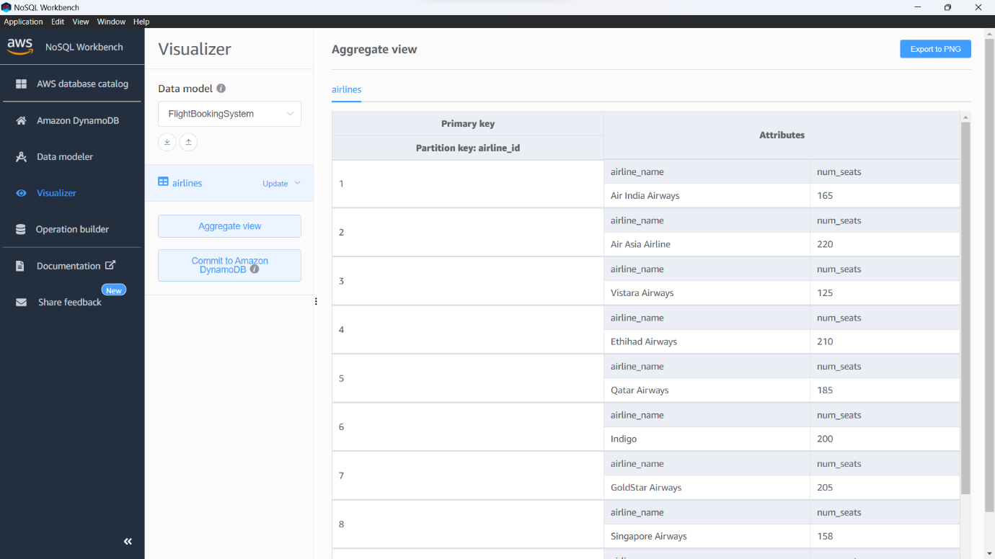

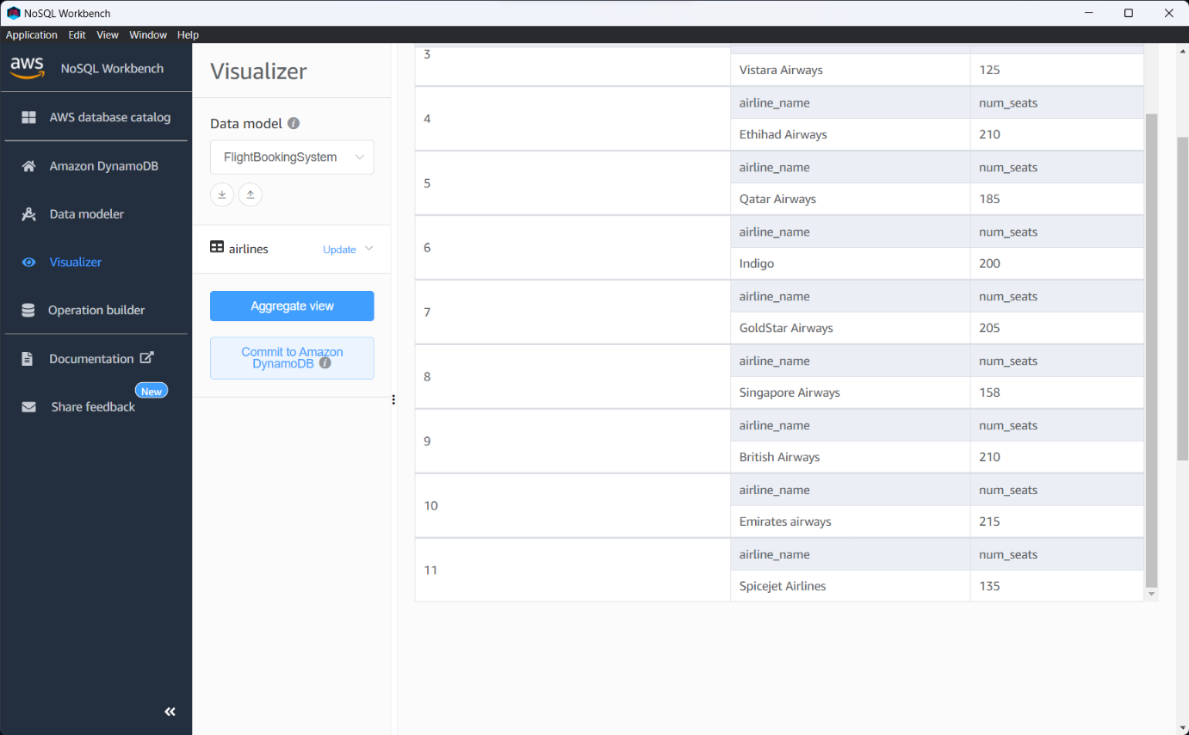

CONCLUSION

In conclusion, the Basic Flight Booking System with PHP and SQL is a robust and efficient web-based application that provides users with an easy-to-use interface for searching and booking flights. Built using PHP and SQL, the system is designed to be secure and reliable, ensuring that users can access up-to-date flight information and make bookings in real-time.

One of the key strengths of the system is its user-friendly interface, which guides users through the booking process and makes it easy to find and book the right flight. The system's search function is intuitive and easy to use, allowing users to search for flights based on their preferred dates, destinations, and other criteria.

Another strength of the system is its secure payment processing, which protects user data and ensures that transactions are completed securely. The system uses industry-standard encryption and secure payment processing to protect user data, providing peace of mind for users and reducing the risk of fraud and other security breaches.

The administrative panel is another key feature of the system, providing airline staff with the tools they need to manage flight schedules, update flight information, and monitor bookings. The centralized location of the administrative panel ensures that flight information is up-to-date and accurate, reducing the risk of errors and other issues.

Overall, the Basic Flight Booking System with PHP and SQL is an excellent solution for airlines and travel agencies looking to streamline their booking process and provide their customers with a top-notch experience. With its user-friendly interface, secure payment processing, and robust administrative tools, the system is an ideal solution for businesses looking to improve their operations and provide their customers with a seamless and efficient booking experience.

APPENDIX-1

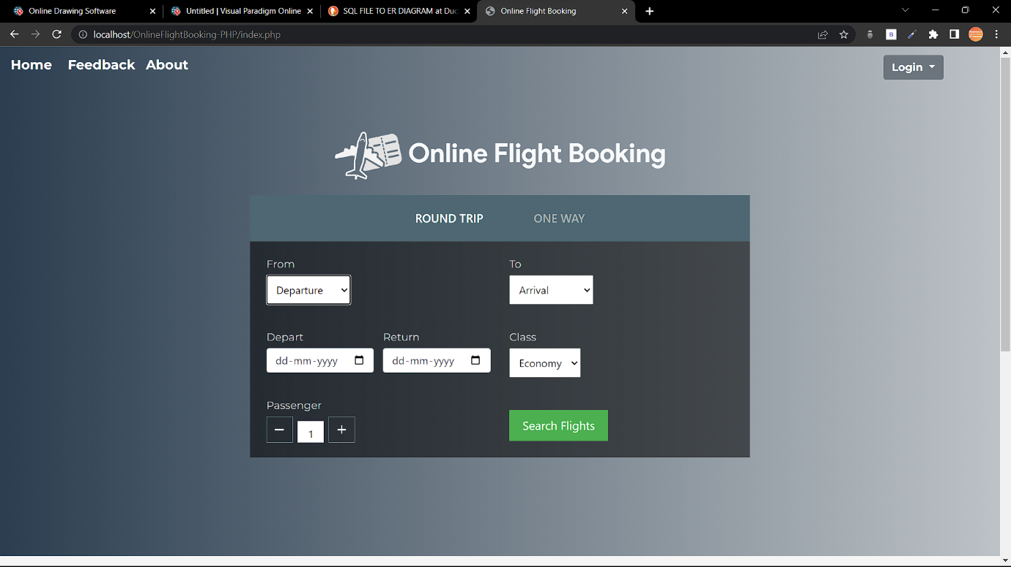
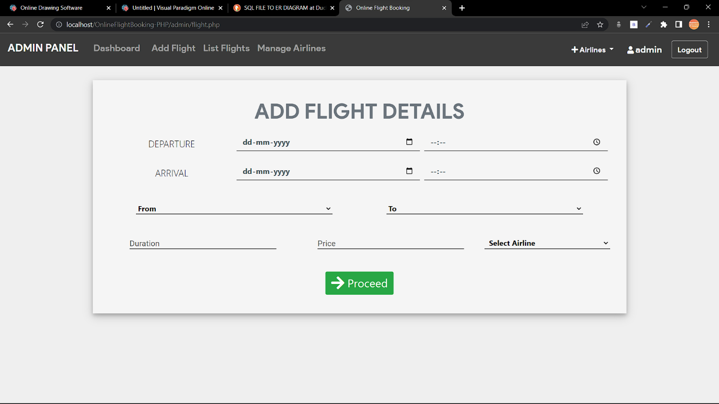
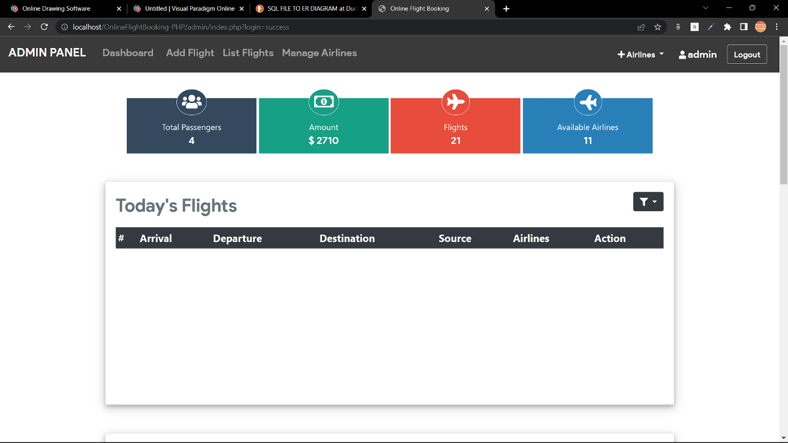
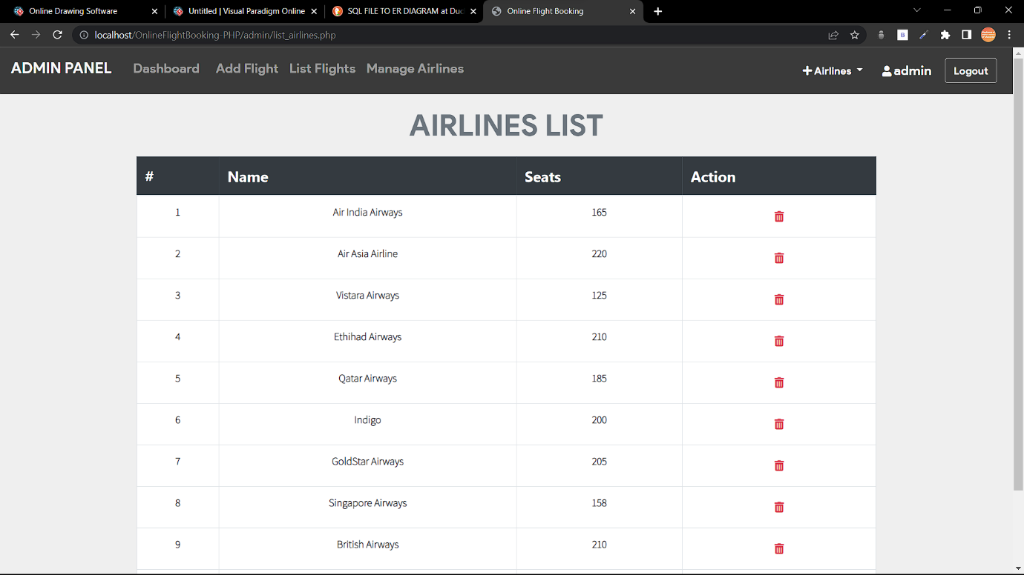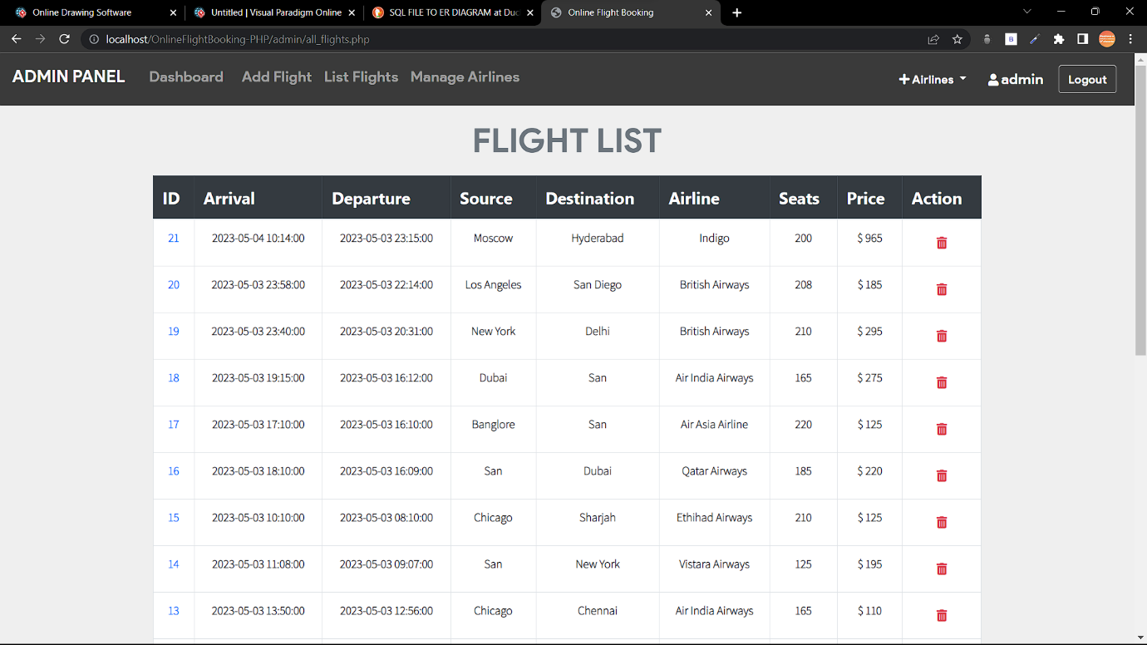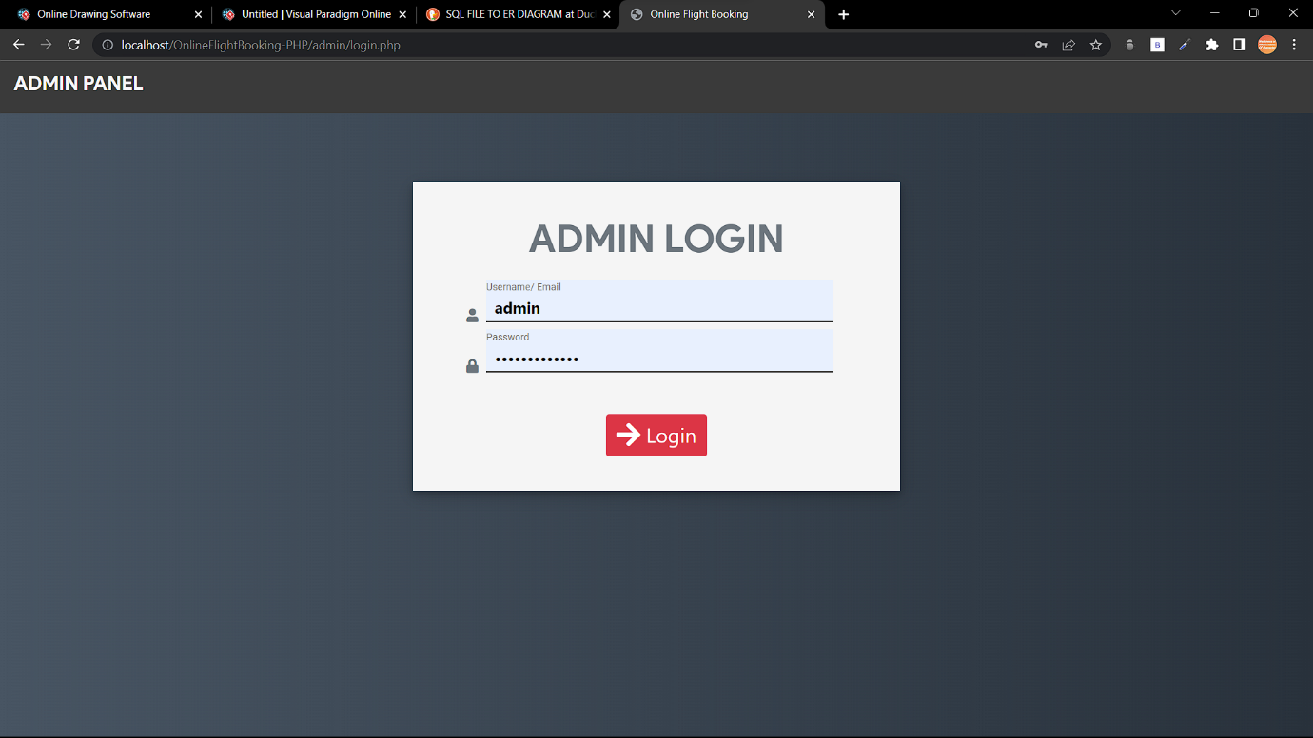
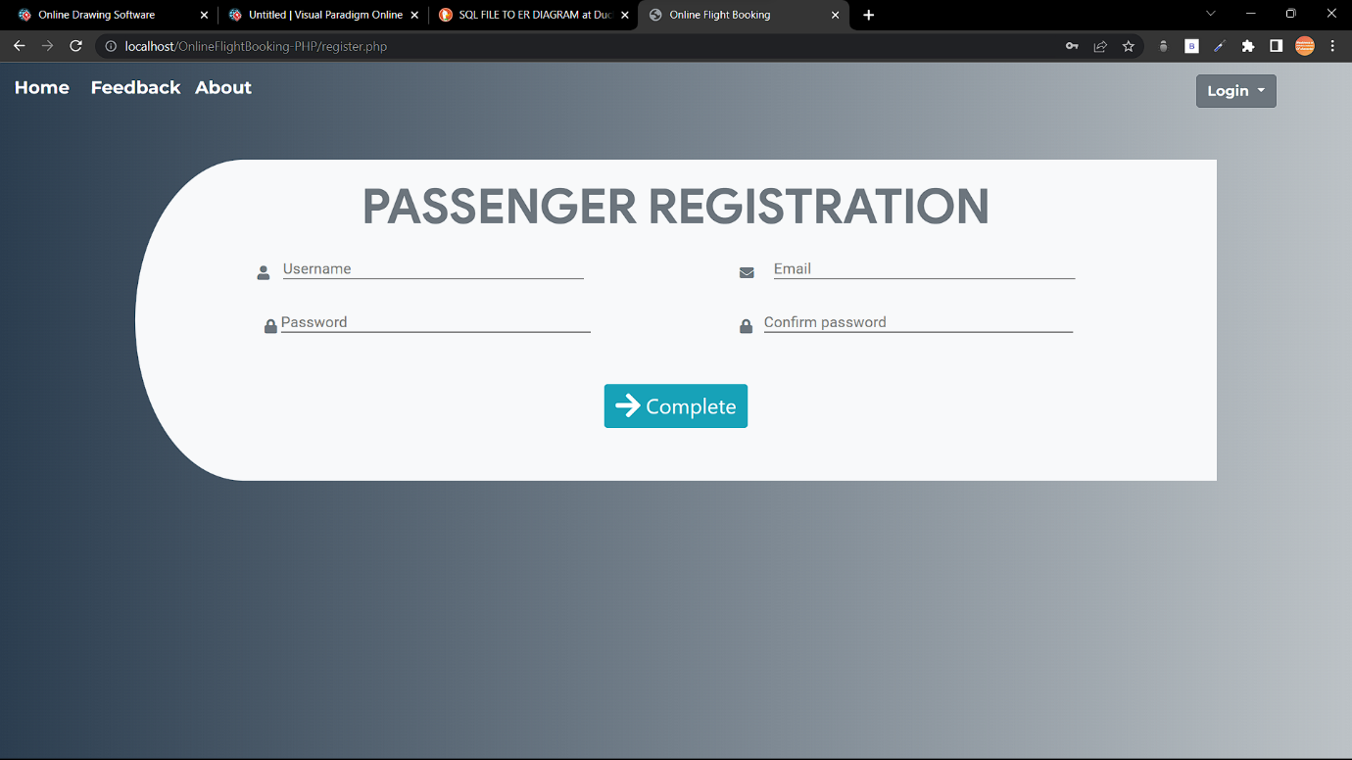

APPENDIX-2

PROJECT LINK:
https://github.com/mahi6148/Flight-booking-system-using-PHP-and-SQL

KANDULA MAHESH’s GITHUB:
https://github.com/mahi6148/
RELLI NAGASAI’s GITHUB:
https://github.com/rs7943

APPENDIX-3

